Student Achievement Data  Semester Course Report - Chemistry Year 11  2019, Semester 1  SAFETY BAY SENIOR HIGH SCHOOL | 

Contents of Report
The following report summarises student achievement information for the Chemistry Course at SAFETY BAY SENIOR HIGH SCHOOL for Semester 1, 2019.
The report provides a compilation of the performance data, including:

- Grade distribution - comparison
- Grade distribution - historical
- Course and exam analysis –comparison
- Course and exam analysis – historical

Opportunities to analyse the data, set targets, identify strategies and resources are provided throughout the report with supporting questions at the end.

Y11 Preliminary Semester 1 2019
Graphs and tables | Analysis of data
Grade Distribution
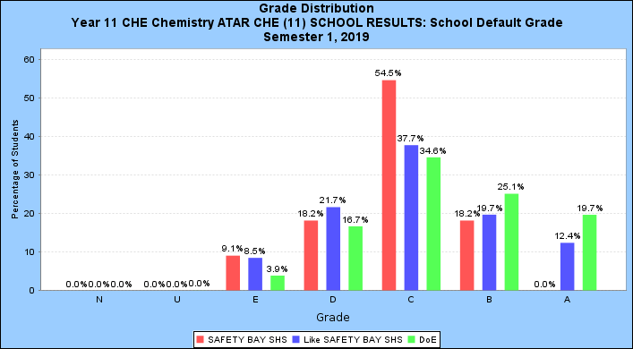

Comparison
 | U | E | D | C | B | A
School |  | 9.1%  (1) | 18.2%  (2) | 54.5%  (6) | 18.2%  (2)
Like Schools |  | 8.5%  (35) | 21.7%  (89) | 37.7%  (155) | 19.7%  (81) | 12.4%  (51)
DoE | 0.0%  (1) | 3.9%  (113) | 16.7%  (481) | 34.6%  (996) | 25.1%  (724) | 19.7%  (567)

Historical
Year | U | E | D | C | B | A
2017 |  | 4.5%  (1) | 27.3%  (6) | 50.0%  (11) | 13.6%  (3) | 4.5%  (1)
2018 |  | 13.3%  (2) | 53.3%  (8) | 20.0%  (3) | 13.3%  (2)
2019 |  | 9.1%  (1) | 18.2%  (2) | 54.5%  (6) | 18.2%  (2)

Graphs and tables | Analysis of data
Course and exam analysis
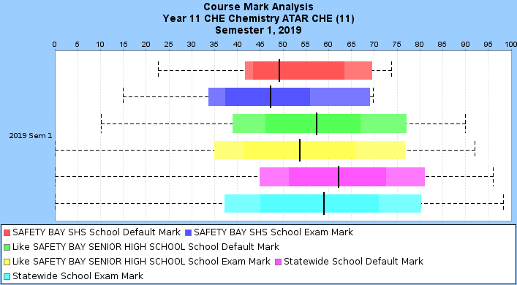

Comparison
 | Students in Course | Students sitting Exam |  | Course | Exam | Diff
School | 11 | 11 | Mean | 51.7 | 46.6 | 5.1
School | 11 | 11 | Std Dev | 13.4 | 15.1 | -1.7
Like Schools | 407 | 405 | Mean | 56.3 | 53.2 | 3.1
Like Schools | 407 | 405 | Std Dev | 15.7 | 17.5 | -1.8
DoE | 2843 | 2824 | Mean | 61.3 | 57.4 | 3.9
DoE | 2843 | 2824 | Std Dev | 15.5 | 18.3 | -2.8

Historical
Year | School  Student Number | Semester 1 |  |  | Semester 2
Year | School  Student Number | School  Mark | Exam Mark | Correlation | School Mark | Exam Mark | Correlation
2017 | 22 | 53.7 | 47.9 | 0.9 | 49.4 | 41.6 | 1.0
2018 | 15 | 43.7 | 43.7 | 0.9 | 46.2 | 39.0 | 0.8
2019 | 11 | 51.7 | 46.6 | 1.0 | 0.0 | 0.0

Reflections and Targets
Summary  - Which of the teaching and learning programs delivered this semester:  - worked well? Why?  1)Atomic structure 2) Pure substances and mixtures 3) Bonding and 4) Chemical reactions  - need to be reviewed? Why?  - Hydrocarbons and calculations  Students haven’t done homework/ revision properly. Most of them struggled with the basic calculation steps. They understood the topic well and completed calculations in class, however, enough revision hasn’t done at home or didn’t fix their knowledge.  Just few students attended homework club to clarify their doubts.  - Where could student performance improve?  - How can teaching and learning programs be adjusted to facilitate improvement?  a) Regularly practice standard exam q’s under test conditions. Mark responses as a whole class and give prompt feedback.  b) Regular checking of homework activities and consequences for the students who are not completing homework on time  c) Explicit teaching of glossary of important terms related to the test/ exam questions  - How will differentiation of teaching and learning programs:  - extend and challenge high performing students?  - Sufficient high order activities or past exam questions challenge and differentiate high performing students from their peers. If the task is too challenging students can discuss among themselves in small groups and can learn from their mistakes.  - Gain the opportunity to organise and voice their thoughts for the benefit of the whole group  - Modelling questions for students. (under exam conditions allow students to do few questions for  10 -15 mins and keep their work separately in a folder)  - support the progress of students ‘at risk’?  - using single worksheet comprised of tasks which get progressively harder. The more advanced students will quickly progress to the later questions whilst students at risk can concentrate on grasping the essentials.  Produce different sets of worksheets/ exercises | Targets  - One of the ‘ B ‘ grade students to achieve an A- grade
Strategies  - Apply Consensus moderation meeting feedback in teaching and learning activities  - Run an invigilated 10 mins activity 2 times a week to prepare students for tests/ exam  - Run homework classes once a week  - Run after school revision session twice a week prior to exam  - Adjusting the timing of assessment tasks according to course outline.  - Emails to parents of students who are receiving unsatisfactory results in assessments  - Send Connect notices prior to assessments | Resources  - Attendance to Consensus moderation meeting  - A bank of past exam type questions  - Encourage students to attend homework classes/ revision sessions
Semester course report – supporting questions

The purpose of this report is to assist teachers to review student performance within a learning area and identify targets for improvement.

These targets may specifically focus on moderating or raising performance in relation to the standards exemplified through the Department of Education’s expected standards:
Strategies implemented to work towards targets such as these can strengthen school based programs, more effectively prepare students for examinations, and engage and motivate students through shared expectations of what they should achieve.

Grade distribution

With reference to the graph and comparison table:
- How does the grade distributions of your school compare to:
- like schools?
- DoE?
- If variations are evident, how can the variations in your schools distribution be accounted for?

With reference to the historical table:
- How consistent is the current distribution of grades compared to the historical data?
- are students beginning to ‘cluster’ in one grade compared to previous grade distributions?
- are students now distributed more widely?
- If variations are evident, how can the variations in your schools distribution be accounted for?
- What teaching and learning adjustments were implemented for the current group compared to previous cohorts?

Course and Exam Comparison
NOTE: Schools set their own exams and standards. Timing and conditions vary between schools.

With reference to the graph and comparison table:
- How did the school performance in the exam compare to their school marks? Are the results ‘as expected’? Discrepancies may include school assessments not being of a similar level of rigour/variety in comparison to the exam. Factors may include: students not handing in assignments or not being prepared for in-class assessments, school assessments that do not ‘extend’ students, an excessive amount of group activity being used for assessment, school assessments not matching the ‘pitch’ or level of difficulty of the exam.

- Can you account for any significant figure in the difference column compared to like and DoE schools for:
- Course mark compared to exam marks? Consider students’ exam preparation, whether school assessments may be marked too ‘hard’ or too ‘easy’, whether there are sufficient in-class invigilated assessments etc.
- Standard Deviation? There are a variety of reasons that may account for any difference. For example, if the spread of marks in the exam is smaller it may be that your stronger students did not do well on the more difficult exam questions. A spread of marks in the exam that is larger than the school spread may indicate too many “easy” marks being awarded to students in school assessments.

With reference to the historical table:
- Are the school and exam performance for the semester comparable to previous years/semester results? Can you account for any differences?
- Consider the correlation between school score and exam score. Has the relative rank order of students based on school marks been maintained (high correlation) or been altered (low correlation)?
Low correlation may be due to an excessive proportion of assessments that don’t replicate exam conditions or standards. If there are multiple classes of the course, it may highlight a lack of internal consistency/moderation.

Reflections and Targets
Summary  - Which of the teaching and learning programs delivered this semester:  - worked well? Why?  - need to be reviewed? Why?  - Where could student performance improve?  - How can teaching and learning programs be adjusted to facilitate improvement?  - How will differentiation of teaching and learning programs:  - extend and challenge high performing students?  - support the progress of students ‘at risk’? |  | Targets for Improvement  - Based on the analysis of the data done above, identify 2 to 3 achievable and measurable performance targets  - Sample targets:  - Reduce difference between course average and exam average from 10.8% to 6.8%  - Two of the 10 ‘D’ grade students to achieve a ‘C’ grade  - Two of the 12 ‘B’ grade students to achieve an ‘A’ grade
Strategies and Resources required to achieve Performance Targets
NOTE: Where possible targets should be discussed with HoLA/TiC and support gained from the student and parents.
- Describe what strategies will need to be implemented to achieve the targets
- Identify what resources will be needed to achieve these targets

Sample strategies and the resources needed to implement them:
Strategies | Resources
Conduct an invigilated 10 minute activity 3 times a week to prepare students for exams | Develop a bank of 30 exam type questions
Conduct after school classes two afternoons a week | - Book room and survey students to determine commitment of students to attend these revision programs  - Develop a program and the associate resources to deliver this revision program
Identify improvement goals for individual students, supported by parents and students | - Student reflection sheets  - Personal target sheets  - Commitment from students and parents

